**AN INTERN REPORT**

**ON**

**RURAL LOCAL GOVERNMENR: A STUDY ON ZILLA PARISHAD,SYLHET**

**Course Title: Internship**

**Course Code: PSS 800A**

**External Supervisor**

**Mr. Sondip Kumar Singha**

**Chief Executive Officer (CEO)**

**Zilla Parishad**

**Sylhet**

**Submitted By**

**Retu**

**Department of political Studies**

**SUST, Sylhet**

**Shahjalal University of Science and Technology, Sylhet-3100**

**Acknowledgement**

Political Studies, as an academic field, involves the integration of both theoretical knowledge and practical experience. The application of theoretical concepts in real-world situations is a crucial aspect of this discipline. My internship took place at Zilla Parishad, Sylhet, where I dedicated 30 days to this practical endeavor.First and foremost, I extend my gratitude to the Almighty Allah for granting me the strength and ability to successfully complete my internship. Following that, I express my sincere thanks to Md. Mahbub Alam ,Assistant Professor in the Department of Political Studies at SUST, and my faculty supervisor, for providing me with the opportunity for this internship. I am deeply appreciative of my Co-Supervisor Mr. Sondip Kumar Singha, Chief Executive Officer at Zilla Parishad, Sylhet. And a special thanks to A K M Kamaruzzaman Masum for guiding me to carry out my internship at the organization and offering unwavering support. I also wish to convey my thanks to Mr. Md. Mofijur Rahman, Surveyor, for including me in field visits, and I appreciate Mr. Nilratan Das for providing insights into Dakbanglo, which significantly contributed to the enhancement of my practical knowledge. Gratitude is extended to the employees and staff of Zilla Parishad, Sylhet, for their warm cooperation.

Lastly, I express my deepest appreciation to my parents for their enduring spiritual support throughout my life.

RETU

Reg. No. 2018235022

Session: 2018-2019

4rth year 2nd Semester

Department of Political Studies

Shahjalal University of Science and Technology, Sylhet.

Contents

**Chapter: One** 6

Introduction 6

Internship Objectives 6

Study Methodology 7

Local Government 7

Structure of Local Government 7

Zilla Parishad 8

History of Zilla Parishad 9

Zila Parishad (Amendment) Act, 2022 11

Amendment of Section 4 of the Act of 2000 11

Zilla Parishd, Sylhet 12

**Chapter: Two** 13

My Learning Session & Activities 13

Functions of Zilla Parishad 13

Compulsory Functions 13

Optional Functions 14

Tender Process 14

Meaning of Tender 14

Tender Procedure 15

Types of Tender 15

Implementation the work and preparing the Bill 17

Training, Scholarship and Donation 17

Training: 17

Providing education scholarships 17

Donations 17

Office Organogram 18

Budget 18

Project adoption, resolution and dispatch to the ministry 21

Receiving letters, sending and Letter File 21

Leasing of Kheyaghat and Land 22

Paying the bill 22

**Chapter Three** 22

Reflection on my whole Internship 22

Monthly Meeting Attendance at Zilla Parishad 23

**Chapter: Four** 24

Limitations of Zilla Parishad 24

Recommendations 24

Conclusion 25

References 25

**Appendix** 26

Abstract

Zilla Parishad operates as an autonomous institution dedicated to the development of the respective district and the upliftment of underprivileged segments of the population through various development projects. Its inception aimed at delivering services at the rural level through these developmental initiatives. The local government system in Bangladesh has undergone a comprehensive historical evolution, shaping the current structure of rural local government institutions over more than two centuries. Post the independence of Bangladesh, significant modifications were introduced to these structures. Given that Union Parishad and Upazilla Parishad are elected bodies, the establishment of Zilla Parishad faced initial resistance from democracy-loving Bangladeshis. To address this, the present government took the initiative and in the history of Bangladesh the first Zilla Parishad elections successfully conducted on December 26, 2016, and secondly on October 17, 2022, with the objective of democratizing this crucial institution, which stands as the highest tier of rural local government.Within the framework of my academic program in the Department of Political Studies, the introduction of an internship (PSS-800A) as a major course worth 3 credits was aimed at allowing students to translate their theoretical knowledge into practical applications. My personal interest in understanding the actual activities of Zilla Parishad led me to select Sylhet Zilla Parishad for my internship. During this period, I had the opportunity to work across various departments and compile a report based on the implementation of development projects observed during my site visits. At the end of the month, on 31 January 2024 I attended a monthly metting of Zilla Parishad which give me a special and realistic experience of a governmental organization.This experience will help me in my future profetional life.Despite encountering challenges during my internship, I successfully addressed them through diligent effort. In the end, my time spent with Zilla Parishad Sylhet not only enriched my knowledge but also provided an enjoyable and interesting experience.

# Chapter: One

## Introduction

Zilla Parishad serves as the topmost level of rural local government in Bangladesh, operating as a district-level service institution. The Bangla term 'Parishad,' meaning council, is translated to 'Zill Parishad,' signifying district council. This tier holds considerable significance within the local government structure of Bangladesh, representing a legacy from the statutory local government (LG) system introduced during the subcontinental era. Originally established in 1885, the district board, functioning as a local government tier at the district level, has undergone numerous transformations over the past 130 years. Presently referred to as "Zilla Parishad," it continues to play a vital role. In our department, the Department of Political Studies, an internship is introduced as a major course (PSS: 800A), allowing students to apply their theoretical knowledge in real-life scenarios. As a Political Studies student, I opted for an internship at Sylhet Zilla Parishad to gain practical insights into its functions. Throughout my internship, I delved into understanding the developmental roles of Zilla Parishad, Sylhet, and compiled my internship report based on development projects and my firsthand experiences.

## Internship Objectives

1. Acquire practical knowledge of Political Welfare, government institution policies, programs, procedures, and services, and understand their impact on the community.
2. Understand the operational activities of Zilla Parishad beyond theoretical learning.
3. Comprehend the implementation process of development projects undertaken by Zilla Parishad.
4. Apply theoretical knowledge in real-life situations.
5. Enhance personal and professional skills through hands-on experience.
6. Investigate the specific functions carried out by Zilla Parishad.
7. Foster a continuous connection between academic and community-level spheres.
8. Cultivate self-awareness, self-discipline, maturity, and confidence while working within a constitutional framework.

## Study Methodology

The methodology employed in this paper relies on data gathered from both direct and indirect sources. Direct information was obtained through interviews with individuals such as the District Council chairman, council administrator, Chief Executive Officer, Zila Parishad, staff, government employees, and contractors.Additionally,indirect information was sourced from the examination of prevailing local government laws, regulations, books, reports, articles, and websites.

## Local Government

Local Government, in simple words, can be defined as an integral part of central government which is established through locally elected representatives to facilitate welfare activities delegated lawfully. Being a bridge, it connects local people with central government providing services and grants. “It is meant for management of local affairs by locally elected persons. If government’s officers or their hence men are brought to run the local government bodies, thereis no sense in relating them as local government bodies” (Kudrat E Elahi Panir vs Bangladesh.1992). It emphasizes on effective participation of local people which can firstly be possible by arrangement of the election in constituting local government. Furthermore, Duane Lockard defines local government as a public organization authorized to decide and administer a limited range of public policies within a small territory that is a sub-division of a regional or national government (Siddiqui, 2005:4), so it is clear that some vested powers of central government are applied by local government in a region only for the benefit of grassroot people.

## Structure of Local Government

Currently there are two distinct local governments in Bangladesh; One for rural areas and one in urban areas. In rural area three levels of local government are introduced: Union Parishad, Upazilla Parishad and Zilla Parishad and City Corporation.

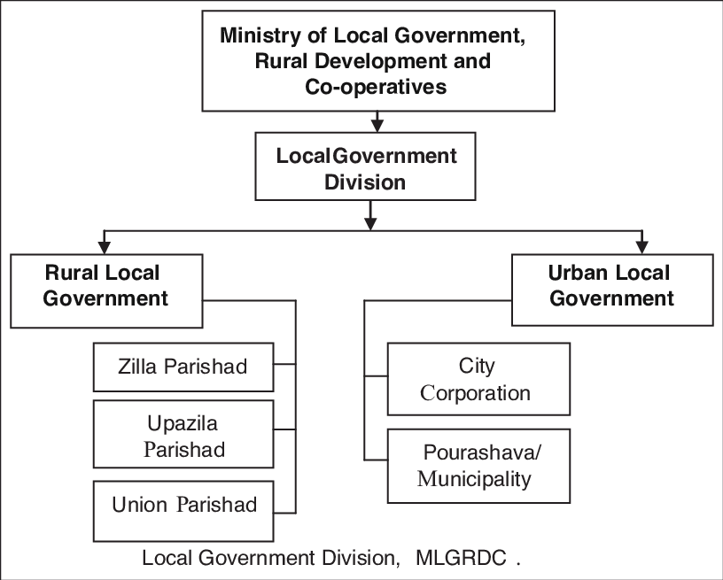

[https:www.researchgate.net-Structure-of-Local-Government-in-Bangladesh_fig1_352353803u](http://https:%20www.researchgate.net-Structure-of-Local-Government-in-Bangladesh-Source-Local-Government_fig1_352353803u)

The structure shows that Zilla Parishad is an important tier of Local Government in Bangladesh and belongs to the rural local government. However, local government includes governmental entity of both elected representatives and selected governing body. The governmental entity which is governed by elected representatives is known as local self-government. Since Zilla Parishad is consists of elected representatives. It falls under the local self-government

## Zilla Parishad

The Zilla Parishad of Bangladesh is a pivotal component of the country's local governance system, serving as the highest tier at the district level. Zilla Parishads coordinate and oversee the implementation of development projects, maintain law and order, and provide essential services within their districts. Comprising elected members, including a chairperson chosen from within, Zilla Parishads ensure representation from diverse communities. These elected bodies facilitate local decision-making, promote autonomy, and engage citizens in the democratic process. As vital hubs for planning and budgeting at the district level, Zilla Parishads contribute significantly to grassroots development. Despite facing challenges, ongoing reforms aim to enhance transparency, accountability, and overall effectiveness, solidifying the Zilla Parishad's role as a linchpin in Bangladesh's local governance framework**.**

## History of Zilla Parishad

Recently, the local government minister indicated that the government could arrange Zilla Parishad elections within the current year under the Zilla Parishad Act 2000. The statement created a ray of hope, as it seemed like under the current government, the 137-year-old dormant institution would be getting an appropriate shape of a legally constituted local government institution. If the government is truly committed to reorganizing the Zilla Parishads, it would obviously be a welcome step, which will complete the whole cycle of local government election and institution. The government will also honor the constitutional provision to have local government institutions in all the administrative units of the country.

There were efforts since the independence to bring political appointees at the district level of all subsequent governments, but no clear step to organize the Zilla Parishads as per the direction of the Constitution was undertaken. The AL government in its first term (1971-1975) took a decision to appoint 'District Governor's in all the districts. The government could not implement the scheme due to the discontinuation of the government after the sad demise of Bangabandhu Sheikh Mujibur Rahman on August 15, 1975. The BNP government in its first term appointed a District Development Coordinator (DDC), who used to hold office at the Zilla Parishad building, but there were no efforts to revive the Zilla Parishad in accordance with the provision of the Constitution of the Republic. The DDCs were given the status of the Deputy Ministersbut the functions were ambiguous and the system ended with the end of BNP rule.

During General Ershad's time in 1988, Zilla Parishads started functioning as a body with appointed Chairs. Mostly Jatiya Party MPs were appointed as Chairs of the Parishads, and they also enjoyed the status of Deputy Ministers. Again, the effort ended with the end of the regime. After a new democratic order since 1990s, the Zila Parishads existed as a physical entity with its age-old building, staff and officials but never functioned as an elected LG unit. It remained as an appendix of district administration for a quite long time and as an office of the ministry of the local government. Under the current government since 2009, MPs of the district along with appointed officials played a major role in the resource distribution of the Zila Parishads.

The latest significant development began with the enactment of the Zila Parishad Act 2000 (though the Act was kept active up to 2012) by the AL government and later, the appointment of Zilla Parishad Administrators in December 2011 under Article 82 of the Act. The administrators are appointed from party rank and file. Some of them are party veterans, former MPs, freedom fighters, retired civil and army officials. They have been drawing salaries of Tk. 27,500, while also receiving facilities such as an entertainment allowance of TK. 3,000 and a vehicle with driver and seven liters of fuel per day. Since the first budget of the People's Republic of Bangladesh in 1972-1973, Zila Parishads have regularly been receiving budgetary allocations from the national government. Almost all the Zilla Parishad administrators have been receiving property allocations and other assets since the British and Pakistan regime. In spite of a regular budgetary allocation, the reason as to why government after government has not shown any concern to reorganize the Zilla Parishads into a properly functional local government institution, remains unclear.

Reorganization of the Zila Parishad in Bangladesh will be a historic event in the existing system of local governance. Since it has been an overdue issue for the last 45 years of Bangladesh, on the eve of this historic moment, we would like to suggest few important measures for the consideration of the government to make the system more representative, accountable and participatory. The existing Zilla Parishad Act has to be amended to hold the election in view of the changes in the formation of the 'Electoral College System', and also to have the party symbols during the electoral contests as other local government bodies followed in the last election.

Our humble suggestion would be to amend the existing Zilla Parishad law for holding election on the basis of universal adult franchise, instead of the Electoral College system. Every eligible voter of the district should be given the chance to choose their representative in the Zilla Parishads. The whole district may be divided into a reasonable number of constituencies or wards based on the number of voters.

One of the studies we recently conducted (Bangladesh: Reform Agenda for Local Governance, Prothom, 2016) suggests that to create Zilla Parishad wards the population and voters need to be considered. There should not be a uniform number of wards and membership, irrespective of population and size of the district. The study suggests 50,000 population and 25/30,000 voters with 10 percent adjustment for matching contiguity, compactness, territorial integrity and convenience of drawing reasonable boundary may form one Zila Parishad Ward. There may be another alternative as well, that at least three constituencies or wards may be created in each upazilla or one upazilla may be divided into three wards of Zilla Parishad - two for general seats and one reserve seat for women. General voters should be given the chance to elect the members from their respective Zilla Parishad wards. After the general election, the chairmen will be elected by the members elected in the respective council from amongst them. If this type of electoral system is created, District Councils may be composed of 30-60 members depending on their size and population. In West Bengal, the Wards of Zilla Parishads vary between 52 to 92, and the number of wards at the village panchayet level varies from 7 to 35. If the Zilla Parishad election is held in 2016, it will be a landmark incident in the history of local government in Bangladesh. We are looking forward to the first ever Zilla Parishad election in Bangladesh with great interest and enthusiasm.

[source: <https://www.thedailystar.net/op-ed/politics/zila-parishad-bangladesh-1274479>]

## Zila Parishad (Amendment) Act, 2022

In pursuit of the outlined objectives and considering the contemporary and essential needs, the Zila Parishad Act, 2000 (Act No. 19 of 2000), has been extensively amended. It reforms the membership of the Zilla Parishad. Changes laws are given below:

### Amendment of Section 4 of the Act of 2000

Section 4 of the Zila Parishad Act, 2000 (Act No. 19 of 2000), shall be replaced with the following sub-section (1):

* The Parishad shall be constituted with the following members:
  + One Chairman;
  + Members equal to the total number of upazilas in the respective district;
  + One-third of the members specified in clauses (a) and (b) shall be female members, based on the nearest whole number; provided that their number shall not be less than 2; and
  + Chairmen of the respective upazila parishads, mayors of municipalities, and representatives of mayors in city corporations, as members."

These are the mendatory part of the amendment of Zilla Parishad Act 2000.

## Zilla Parishd, Sylhet

Sylhet Zilla parishad has 13 Upazillas. These are: Sylhet Sadar, Osmaninagar, Bishwanath, Balaganj, Dakshin Surma, Fenchuganj, Companiganj, Gulapganj, Jaintapur, Gowainghat, Kanaighat, Zakiganj and Beanibazar.

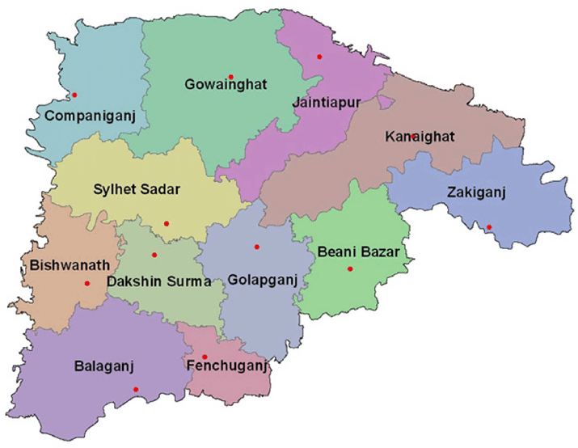

**[ Figure: Upazillas of Sylhet Zilla Parishad]**

# Chapter: Two

## My Learning Session & Activities

## Functions of Zilla Parishad

According to Zilla Parishad act 2016, The functions of Zilla Parishad are two types. These are:

Types of Functions

Compulsory

Optional

## Compulsory Functions

* Scrutiny of development efforts within the district.
* Construction, Maintenance and development of roads, culverts, and bridges not owned by the pourashava and government.
* Establishment and maintenance of public libraries.
* Plantation and conservation of roadside trees.
* Promotion and Maintenance of gardens, playground, and open fields for public use.
* Management and development of ferry ghats not maintained by the pourashava or Upazilla Parishad.
* Association with other institutions performing same types of functions.
* Assistance, Association encouragement to Upazilla Parishad and Pourashava.
* Construction and Maintenance of Dak Bungalows and rest houses.
* Execution of development plan entrusted by the government.

## Optional Functions

* Establishment and Maintenance of School.
* Establishment and Maintenance of student hostels.
* Arrangement of scholarship.
* Teachers Training.
* Planning for education and execution of plan.
* Establishment and Maintenance of information center.
* Development and sports culture.
* Establishment of Museum and art gallery.
* Establishment of public hall and community.
* Measures of developing culture.
* Organizing volunteers for social service.
* Legal aid for the poor.
* Welfare activities for women and backward families.
* Preservation of forests in villages.
* Establishment, control and maintenance of Markets.
* Collection of raw materials and arrangement of marketing.
* Development of health-related education.
* Establishment and maintenance of primary health care.
* Encouragement and committees and medical assistance.
* Development of communication system.
* Arrangement for the development of religious, moral and other matters.

## Tender Process

### Meaning of Tender

A tender is a written request sent to potential suppliers to ask for information required for the buyer to then evaluate & select a preferred supplier.

### Tender Procedure

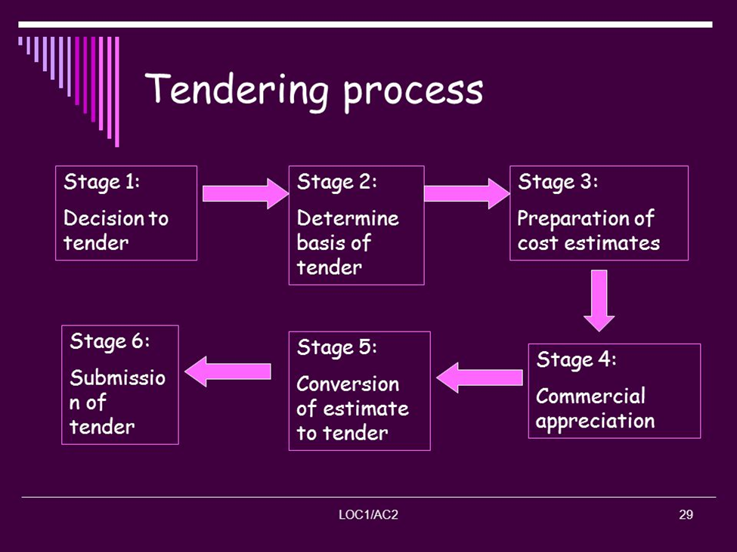

**[Figure: Tender Process]**

### Types of Tender

1. Limited Tender Method (LTM)
2. Open Tender Method (OTM)
3. Request for Tender (RFQ)
4. Direct purchasing Method (DPM)
5. OSTETM Tender
6. TESTETM Tender

Types of Tender

OTM Tender

OSTETM Tender

**Limited Tender Method (LTM):** Enlisted contractors of Zilla Parishad can call for its types of tenders. PE can call the tender 5% less or 5% above from the estimated cost of the project who calls the lowest cost win the tender. If more than one lowest call the winner is selected by lottery.

**Open Tender Method (OTM):** Any PE around the country can call for the tender. The calls can be 10% less or 10% above from the estimated cost of the project. No lottery but four categories is used for selecting the winner.

**Request for Tender (RFQ):** In ADP the budget the RFQ can be up to 10 lakhs for services. But in revenue budget RFQ can be up to 6 lakhs for works and up to 3 lakhs for services.

**Direct purchasing Method (DPM):** DPM can be up to tk. 25000 in both ADP and own budget for both work and services. Other types of tender OSTETM and TESTETM are less used on Zilla parishad.

After selecting PE performance security ids given by him, assistant sub engineer visits the site and prepare layout of the project. Then, the Parishad provides working order to the contractor to work on basis of layout. If he changes layouts, he will be personally responsible for the cost since Zilla Parishad will provide definite allotment. However, after working order is given, the projects start to get implemented. After the project is completed, the contractor applies for getting total amount of money for project. Sometimes the contractors apply for getting money after completed 50% of work and paid the bill is called “Running Bill”. The Parishad considers the opinion of sub-assistant engineer. After the bill goes to the assistant engineer, and after his approval the bill goes to the accountant and then go to the assistant engineer and from him ton the chairman and CEO. After their approval, it goes to the accountants again and he passes the bill after scrutinizing carefully. After the implantation of project, the performance security is returned to the contractor on the basis of his application after one year of providing total allotment.

<https://www.google.com/.com%2Fslide%2F1421346%2F&psig>

## Implementation the work and preparing the Bill

After the appointment of the contractor, when 30% of his work is completed, then on the basis of contractor application he get a running bill and after the full complement of the work the contractor gets the final bill and previous running bill is considered along with the final bill.The bill is prepared by two way such as:

1. Sub- Engineer and
2. Assistant Engineer.

There are three types of bills such as project committee, tender and Boucher.

## Training, Scholarship and Donation

### Training:

Educated unemployed, youth and women are trained by the Zilla Parishad.

There are various types of training such as,

* Driving Training (every year 100 students).
* Computer Training 120 students.
* Sewing Training and freelancing.
* Plumbing and fitting Training.

### Providing education scholarships

Who are Passed with good result at SSC and HSC such as Science group GPA 5 out of 5 and Humanities group & business group required is GPA 4.50 out of 5. They are selected for the scholarship basis of application.

### Donations

Whose are affected the serious crisis of money, owed, serious poor patient, poor individual, institutions and unable to give the marriage of girl. they are selected for getting donation.

### Office Organogram

Organogram is an intuitive reflection of organization structure, one of the most common diagrams to illustrate the relationships among departments, superiors, and subordinates vividly and briefly. The organogram of Zilla Parishad according to Zilla Parishad Act 2016 is given below:

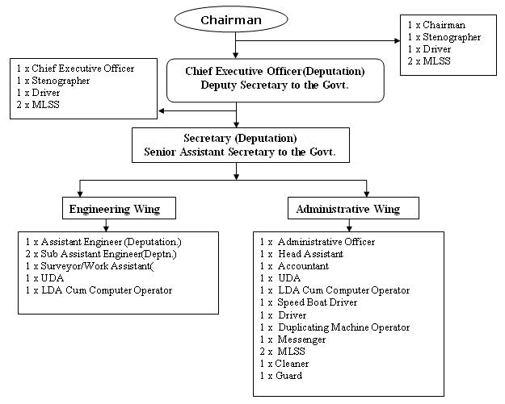

Chief Executive

[Source: <https://www>.zpbagerhat.gov.bd/wp-content/uploads/2015/07/123.jpg]

### Budget

There are two types of funds or budget for conducting development activities of Zilla Parishad under development project. These are:

Budget

Own Budget

ADP Budget

#### Own Budget

The money earns by Parishad from several sources under its control or maintenance is called own fund. Zilla Parishad allot considerable amount of money from its own fund for completing development projects in every fiscal year. The Parishad earns or taken budget from the following sources,

* Tax on the transfer of immovable property.
* Income from lease of lands.
* Income from lease of ponds.
* Income from lease of Ferry ghats.
* Income from the Dakbanglaw.
* Income from the rent of auditorium and picnic center.
* Income from the housing state.
* Income from the Markets/storehouse/shop.

#### Annual Development Program (ADP)

Development planning is considered to be the most important aspects of government’s fiscal policy. ADP came from government as a development project. Approved projects are shown in funding arrangements in the ADP. On the other hand, unapproved projects are also shown in the ADP in its own separated section generally listed without the funding arrangement. In every fiscal year, Government provides a definite amount of money to Zilla Parishad through ADP for development projects and Parishad employees this allotment for the development of districts by giving contractors at 5% less of allotment. This saved 5% get included with own fund.

The following pictures show that the annual Income and Expenditure were taken from Own and ADP in 2023-2024 a fiscal year.

#### Leasing of Pond

Advertisements are given in the newspaper in the case of leasing the pond. Then those who are interested take the auction and lease the pond. The pond is leased out for 3 years.

#### Elected Parishad

Zilla Parishad is consisting of an electing governing body. The last elected parishad lists are given in a picture.

#### Property and Market

Housing estate and market are one of the properties owned by the district council. These are given through lease for a period of 99 years.

#### Contractor enrollment and renewal

First, the contractor has to obtain a trade license. Trade licenses can be obtained from the office of the ward commissioner of the district council, municipality, or City Corporation. Second, Tax Identification Number or TIN must be done and certificate must be there. Third, Specific forms have to be collected from the district council. The price of the form is Tk 10. In this case, different amounts of fees are applicable according to the type of business. Along with the application form, 3 copies of photographs, rent agreement letter and rent receipt, tax payment receipt along with the tax officer have to apply. In the case of limited companies, copies of Memorandum are to be submitted. Then the original trade license book can be collected on the basis of the necessary verification.

There are different types of businesses in vogue.

1. A proprietorship/privately owned company.
2. Partner organizations.
3. Joint Capital Company (Private Limited Company / Public Limited Company)

#### Renewal of license

Renewal of license is a regular process. The trade license is accompanied by a renewal invoice book. Renewal can be done on a year-wise basis by depositing the required fees in the designated bank.

## Project adoption, resolution and dispatch to the ministry

In the monthly meeting, the project is divided according to the proportion of the upazilla and the elected members take up the project. If two-thirds of the approval is received in the monthly meeting, it is sent to the ministry. And when the ministry approves the project, it is accepted and implemented.

### Receiving letters, sending and Letter File

* **Receiving letters**: When the application form related to the Zilla Parishad is sent directly by post from different individuals, offices, ministries, the letter comes to the receiving branch and is sent to the seen file. All the letters that come to the chairman and CEO branch are sent separately to the seen file of the chairman and CEO branch.
* **Sending Letters:**Implementing the related issues is sent to the ministry office and from the related branch is provided to send all letters.
* **Letter File:** In order to send letters to any office located in the local or Sylhet Sadar, they have to be sent by entering the peon book.The person in charge of the office where the messenger sends the letter gives signatures that the person in charge of the office has received the letter in the peon book. Not only that, many times the head of the office issues various office orders to complete various tasks. They are signed by the person or assistant peon in charge of the concerned branch and receive the letter.

### Leasing of Kheyaghat and Land

A notification was issued for leasing out the kheyaghat and land of the zilla parishad. The land, or kheyaghat, is leased for a year in accordance with the prescribed procedure.At present there are 73 Kheyaghat under the Zilla Parishad.

### Paying the bill

The bill is paid with the approval of the Chairman and Chief Executive Officer (CEO) of the Zilla Parishad. In the case of retail expenses. There are three types of bills such as project committee, tender and Boucher. more than 25,000 bills are not approved.

**Website:** [www.zp.sylhet.gov.bd](http://www.zp.sylhet.gov.bd)

# Chapter Three

## Reflection on my whole Internship

During my Internship at Zilla Parishad, Sylhet. I worked on multiple tasks and activities both in office and field level. I worked in all of departments of zilla Parishad.

**Project Site Visit:** I visited the project site with surveyor Mr. Mofizur Rahman which is located at the area of Zilla Parishad where the parking garage and a

library are being made.

**Maintenance of property**

The property of the Zilla Parishad is marked in the record book specified in the District Council. All the properties of Zilla Parishad are number 2. Everything is taken care of by the surveyor based on his work guidelines.

**Dakbanglo**

I had visited the ‘Dakbanglo’ with my team members and our trainer Mr. Nilroton Das. It was my new experience to visit the ‘Dakbanglo’. I have witnessed how dakbanglo are rented out and is cared for. The cost of stay in Dakbanglo for government officials is 200 per night and 600 for the general public.

## Monthly Meeting Attendance at Zilla Parishad

I have attented a monthly metting that held in Zilla Parishad and I have learned something new from monthly meeting these are mentioned below.

* Monthly meeting held in every month a one time. There may be more than one on an emergency basis.
* Developmental issues were discussed.
* Winter clothes will be distributed among the needed persons.
* The project of Baish Tila is granted by the Ministry.
* Education Scholarship will be distributed among 10 autistic students.
* The vacant post ( lower division assistant and an electrician) will be filled through the circular.
* The pond of Amberkhana Borobazar will be reconstructed. etc.

**Practical Knowledge:** The journey with Zilla Parishad, Sylhet was a practical knowledge for me. I have learned many thinks through different kinds of lectures, visiting sites, mettings ect. Especially the monthly meeting of Zilla Parishad was an exceptional experience where the Chairman of Sylhet Zilla Parishad Md. Nasir Uddin Khan, The Chief executive Officer (CEO) of Sylhet Zilla Parishad Mr. Sondip Kumar Singha, the Chairmans , Members of the Zilla Parishad Sylhet , and the officials were present.There was an special guest Mr. Anuyaruzzaman Chawdhury mayor of Sylhet City Corporation was present.

# Chapter: Four

## Limitations of Zilla Parishad

Zilla Parishad has some limitations. The limitations I witnessed during my internship are discussed below.

* Though ZP is an autonomous institution, it cannot approve a single development project.
* The Parishad is not completely digitalized yet. The officials do the tender

related activities online but they have to keep record manually in the file which is causing the double work for them and leading to exceeding work pressure.

* Engineers are compulsory for the completion of development projects but the Parishad have no Engineers of its own. All of them including Assistant Engineer and SubAssistant Engineers are on the deputations from LGED.
* The opinions of beneficiaries are not considered well during the project approval and implementation process.
* The Parishad doesn’t provide transport facilities to the Engineers for visiting project site.

## Recommendations

* The number of employees should be increased to minimize the huge workload.
* The number of women employees should be increased as an incentive to contribute to women empowerment.
* The website of ZP needs regular updates so that everyone can get fast information.
* The Parishad should have its own Engineers.
* The Parishad should provide transport facilities to the sub-Assistant Engineer for site visit.
* Development project of Zilla Parishad should be implemented within limited time.

## Conclusion

My internship period at Zilla Parishad, Sylhet was beneficial for me. I have gained new knowledge and developed new skills. Before internship, I didn’t know the actual functions of Zilla Parishad but after internship I have learned that it does a lot of activities to develop the district through development projects. I studied project formulation, approval and implantation process at my academic level, Internship helped me to know these processes in the practical field. During my internship I got opportunity to know the skills I have and to achieve new skills and knowledge. I got opportunity to meet a lot of people and know their perception about politics and other things which helped me to develop my understandings. I am very much thankful to the people who helped me to complete my internship period. I believe that the experience I gathered during my internship will help me in personal and professional life.

## References

1. Nishat, Md Abu Jakaria, et al. "Functioning of Local Government in Bangladesh: Legal and Practical Spheres." Advances in Social Sciences Research Journal 8.11 (2021).
2. Siddiqui, K., Ahmed, J., Siddique, K., Huq, S., Hossain, A., Nazimud-Doula, S., & Rezawana, N. (2016). Social formation in Dhaka, 1985–2005: a longitudinal study of society in a third world megacity. Routledge.
3. Siddiqui, Kamal, et al. social formation in Dhaka, 1985–2005: a longitudinal study of society in a third world megacity. Routledge, 2016.
4. Panday, Pranab Kumar. "Local government system in Bangladesh: How far is it decentralised?" Lex Localis-Journal of Local Self-Government 9.3 (2011)

6.https://www.thedailystar.net/op-ed/politics/zila-parishad-bangladesh

1. <http://zpsylhet.gov.bd>

# Appendix

|  |  |  |
| --- | --- | --- |
| Date | Subject Matter | Assignee |
| 21.12.2023 - 24.12.2023 | To give an idea on the overall activities of the Zilla Parishad | Chief Executive Officer  Zilla Parishad, Sylhet |
| 26.12.2023- 31.12.2023 | Zilla Parishad functions.  Approved work tender process.  Execution of work and preparation of bills | Mr. Surjasen Roy |
| 01.01.2024 - 04.01.2024 | Formation and History of Zilla Parishad; training; providing education scholarships; Donations | Mr. A.K.M.  Kamruzzaman  Masum |
| 08.01.2024 - 11.01.2024 | Office Organogram; the budget.  Leasing (Pond).  the elected council; Properties and Markets; | Mr. Delwar Hossen Zoyaradar |
| 14.01.2024 - 18.01.2024 | Contractor enrollment and renewal; project acceptance, resolution and transmission to the Ministry | Mr. Dhirendra Kumar Singha |
| 21.01.2024 - 24.01.2024 | Receiving letters, sending letters and issuing peons.  Relating to Leases (Kheyaghat and Land) | Mrs. Bornali Das |
| 25.01.2024 | Paying bills.  website; | Mr. Md. Nazim Uddin |
| 28.01.2024 | Dak bungalow | Mr. Nilratan das |
| 29.01.2024 - 30.01.2024 | Attending at monthly meeting | Mr. Mofizur Rahman, Surveyor |
| 31.01.2024 | Attending Monthly Meeting | Chairman and Chief Executive Officer  Zilla Parishad, Sylhet |